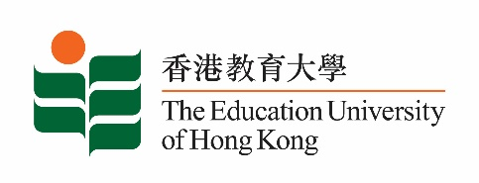
致： 傳媒機構採訪主任 (共 1頁) 18 June 2021
To : News Editors (total: 1 pages)

香港教育大學2021年6月21日至7月4日可供採訪之活動一覽
The Education University of Hong Kong (EdUHK) Events Calendar for 21 June to 4 July 2021
本校誠邀 貴機構派員採訪下列活動。傳媒查詢，請聯絡教大傳訊處（電話：2948 6050）。
You are cordially invited to cover the events below. For media enquiries, please contact the Communications Office at 2948 6050.

因應2019冠狀病毒疫情，以下活動或有人數限制，傳媒請預先向主辦部門登記。
In light of the COVID-19 pandemic, there may be restrictions on the number of participants for the following event(s). Please contact the respective organiser(s) / department(s) for prior registration.

- 教大大埔校園 （新界大埔露屏路十號） / EdUHK Tai Po Campus (10 Lo Ping Road, Tai Po, New Territories)

日期  Date | 時間  Time | 活動  Event | 地點  Venue | 主辦部門及公眾查詢  Organiser &  Public Enquiry | 備註  Remarks
2021-07-03 | 11:00 am – 4:30 pm | 《以A為焦點的STEAM教學》教材分享會  Teaching Material Sharing: An A-focused STEAM Teaching | 線上講座  ZOOM  (連結將於報名後經電郵發送)  (Zoom link will be provided via email after registration)  報名方法 / Registration:  https://forms.gle/sosVvy1ZVzCkF4bbA | 主辦部門 / Organiser:  教大文化與創意藝術學系  Department of Cultural and Creative Arts of EdUHK  查詢 / Enquiries:  鍾小姐Miss Zhong  電郵 / Email:  szhong@eduhk.hk  電話 / Tel:  2948 6883 | 歡迎視藝科及對STEAM有興趣的老師參與；教材書數量有限，先到先得，送完即止。  Visual Arts teachers and teachers who are interested in STEAM are welcome to join. Limited copies of teaching materials are available on a first come first served basis.

